
MUFG Union Bank, N.A.

GSI Update Program
For East Quality Center Using Macro

Submitted By
Test Management Tools Team

Table of Contents

1 Introduction: 2
2 Update GSI information in HPQC – TEMPLATE_MUFG 2
3 Steps to Download GSI Data from Systems (GSI) 5
4 How to use the GSI Update Program: 7
5 Data Upload Validation 8
6 Support 9

Introduction:
This document describes the weekly update/re-publish of the Global System Inventory (GSI) application and stakeholder’s information in HP QC using a custom macro described in this document. Along with the process that needs to be followed to update HPQC defect form fields, under GSI update column.

This document assumes that you have administrative rights of the QC system. It is assumed that the administrator understands basic systems administration principles and has a general background in SQL database, QC API programming, Excel macro as well as a background in SDLC and Quality testing concepts.
These instructions are based on the current landscape in the East Quality Center Production and Test environments at MUFG Bank. Furthermore, these instructions have been validated in the East Quality Center Test Environment.
Below are names of 10 dropdown lists of TEMPLATE_MUFG, which will be considered under weekly GSI update:
- gsi-system-id
- gsi-smnameonly
- gsi-sysmanager
- gsi-pmnameonly
- gsi-portfoliomgr
- gsi-lvl2businessexecutive
- gsi-lvl2businessunit
- gsi-lvl3businessexecutive
- gsi-lvl3businessunit
- gsi-heritage

Update GSI information in HPQC – TEMPLATE_MUFG:

Pre-requisites:

GSI Upload for East.xlsm file

OTA client needs to be downloaded

Admin access to HPQC project ‘Template_MUFG’ under domain ‘TEMP’

Take the Backup from TEMPLATE_MUFG Project

Execute the SQL Query named ‘GSI Upload Backup’ from dashboard module of TEMPLATE_MUFG project for required Lists and save them offline.
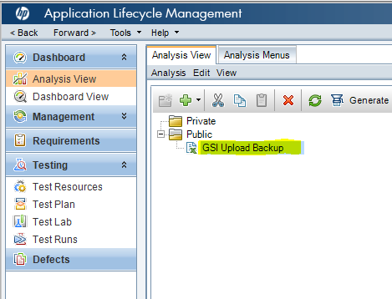

Queries:
gsi-system-id:
SELECT lf.fatherName, ld.ls_name
FROM LISTS ld,
(SELECT ls_id AS fatherId, ls_name AS fatherName
FROM LISTS
WHERE ls_name in ('gsi-system-id') ) lf
WHERE ld.ls_father_id =lf.fatherId

gsi-smnameonly:
SELECT lf.fatherName, ld.ls_name
FROM LISTS ld,
(SELECT ls_id AS fatherId, ls_name AS fatherName
FROM LISTS
WHERE ls_name in ('gsi-smnameonly') ) lf
WHERE ld.ls_father_id =lf.fatherId

gsi-sysmanager:
SELECT lf.fatherName, ld.ls_name
FROM LISTS ld,
(SELECT ls_id AS fatherId, ls_name AS fatherName
FROM LISTS
WHERE ls_name in ('gsi-sysmanager') ) lf
WHERE ld.ls_father_id =lf.fatherId

gsi-pmnameonly:
SELECT lf.fatherName, ld.ls_name
FROM LISTS ld,
(SELECT ls_id AS fatherId, ls_name AS fatherName
FROM LISTS
WHERE ls_name in ('gsi-pmnameonly') ) lf
WHERE ld.ls_father_id =lf.fatherId

gsi-portfoliomgr:
SELECT lf.fatherName, ld.ls_name
FROM LISTS ld,
(SELECT ls_id AS fatherId, ls_name AS fatherName
FROM LISTS
WHERE ls_name in ('gsi-portfoliomgr') ) lf
WHERE ld.ls_father_id =lf.fatherId

gsi-lvl2businessexecutive:
SELECT lf.fatherName, ld.ls_name
FROM LISTS ld,
(SELECT ls_id AS fatherId, ls_name AS fatherName
FROM LISTS
WHERE ls_name in ('gsi-lvl2businessexecutive') ) lf
WHERE ld.ls_father_id =lf.fatherId

gsi-lvl2businessunit:
SELECT lf.fatherName, ld.ls_name
FROM LISTS ld,
(SELECT ls_id AS fatherId, ls_name AS fatherName
FROM LISTS
WHERE ls_name in ('gsi-lvl2businessunit') ) lf
WHERE ld.ls_father_id =lf.fatherId

gsi-lvl3businessexecutive':
SELECT lf.fatherName, ld.ls_name
FROM LISTS ld,
(SELECT ls_id AS fatherId, ls_name AS fatherName
FROM LISTS
WHERE ls_name in ('gsi-lvl3businessexecutive') ) lf
WHERE ld.ls_father_id =lf.fatherId

gsi-lvl3businessunit:
SELECT lf.fatherName, ld.ls_name
FROM LISTS ld,
(SELECT ls_id AS fatherId, ls_name AS fatherName
FROM LISTS
WHERE ls_name in ('gsi-lvl3businessunit') ) lf
WHERE ld.ls_father_id =lf.fatherId

gsi-heritage:
SELECT lf.fatherName, ld.ls_name
FROM LISTS ld,
(SELECT ls_id AS fatherId, ls_name AS fatherName
FROM LISTS
WHERE ls_name in ('gsi-heritage') ) lf
WHERE ld.ls_father_id =lf.fatherId

Steps to Download GSI Data from Systems (GSI):

Download the GSI data from the below given URL: http://ubeaintranet/sites/ubea/default.aspx

Click on “GSI Full Extract”, to download the data.

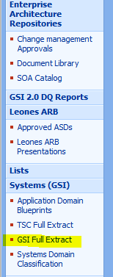

In “GSI Full Extract” excel file, in the “GSI Production” sheet “Development Status” column would only accept “Production” status, refer the screenshot below.

Whereas, in “GSI Non-Production” sheet “Development Status” column would on accept “Development” status. For a better understanding a screenshot has been given below.
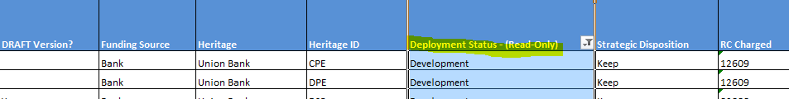

How to use the GSI Update Program:

Open “GSI Upload for East” excel file, now copy filtered data from ‘GSI Production’ sheet of ‘GSI Full Extract’ file. Paste the data in ‘GSI Production’ sheet of ‘East GSI Upload’ file.

Copy the filtered data from ‘GSI Non Production’ sheet of ‘GSI Full Extract’ file and paste it to ‘GSI Non Production’ sheet of ‘East GSI Upload’ file.

Open “GSI Upload for East” excel file and click on “Go…Go…Go…”, as given in the screenshot below.

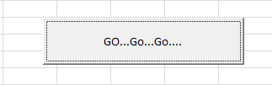

Sheet_Details page will open with the names of columns in Production and Non-Production Sheets.

These two columns are customizable and if all the fields are correct then click on Next¸ as highlighted in the screenshot below.
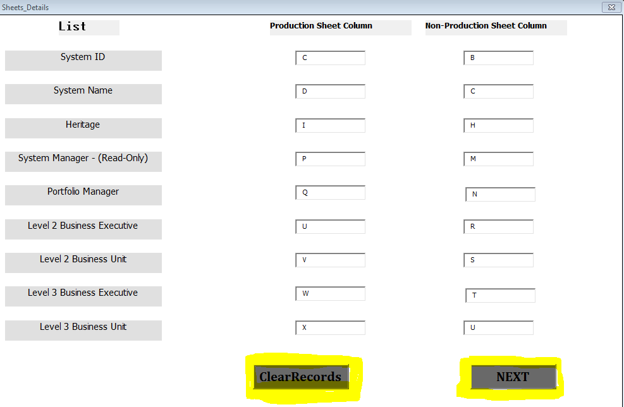
Note: Also, there is a Clear Record button, i.e. to clear any existing records in the file.

Data Upload Validation:

A user can validate data upload by tracking Project List, as these names would also act as progress check status bars. When the project name changes to blue from grey, which implies that the transfer is complete.
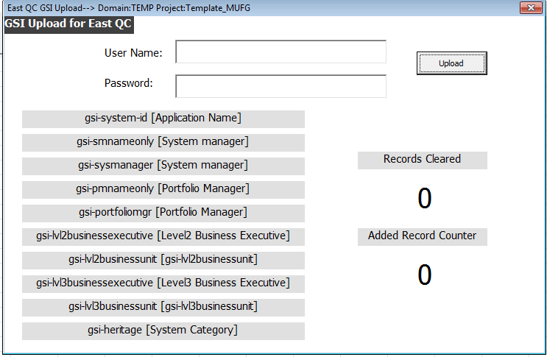

The two counters on the right bottom of the page give the following information:

Records Cleared – Implies the number of records that have been cleared against each GSI field, which are already in QC.

Added Record Counter – Gives the number of records that have been added to each GSI field.

Support:
In case, any training on Site Admin is required, feel free to contact HQC Admin group.

E-mail - ITG-QETestTool-Support@unionbank.com

